FUTURE LEADERS CANADA

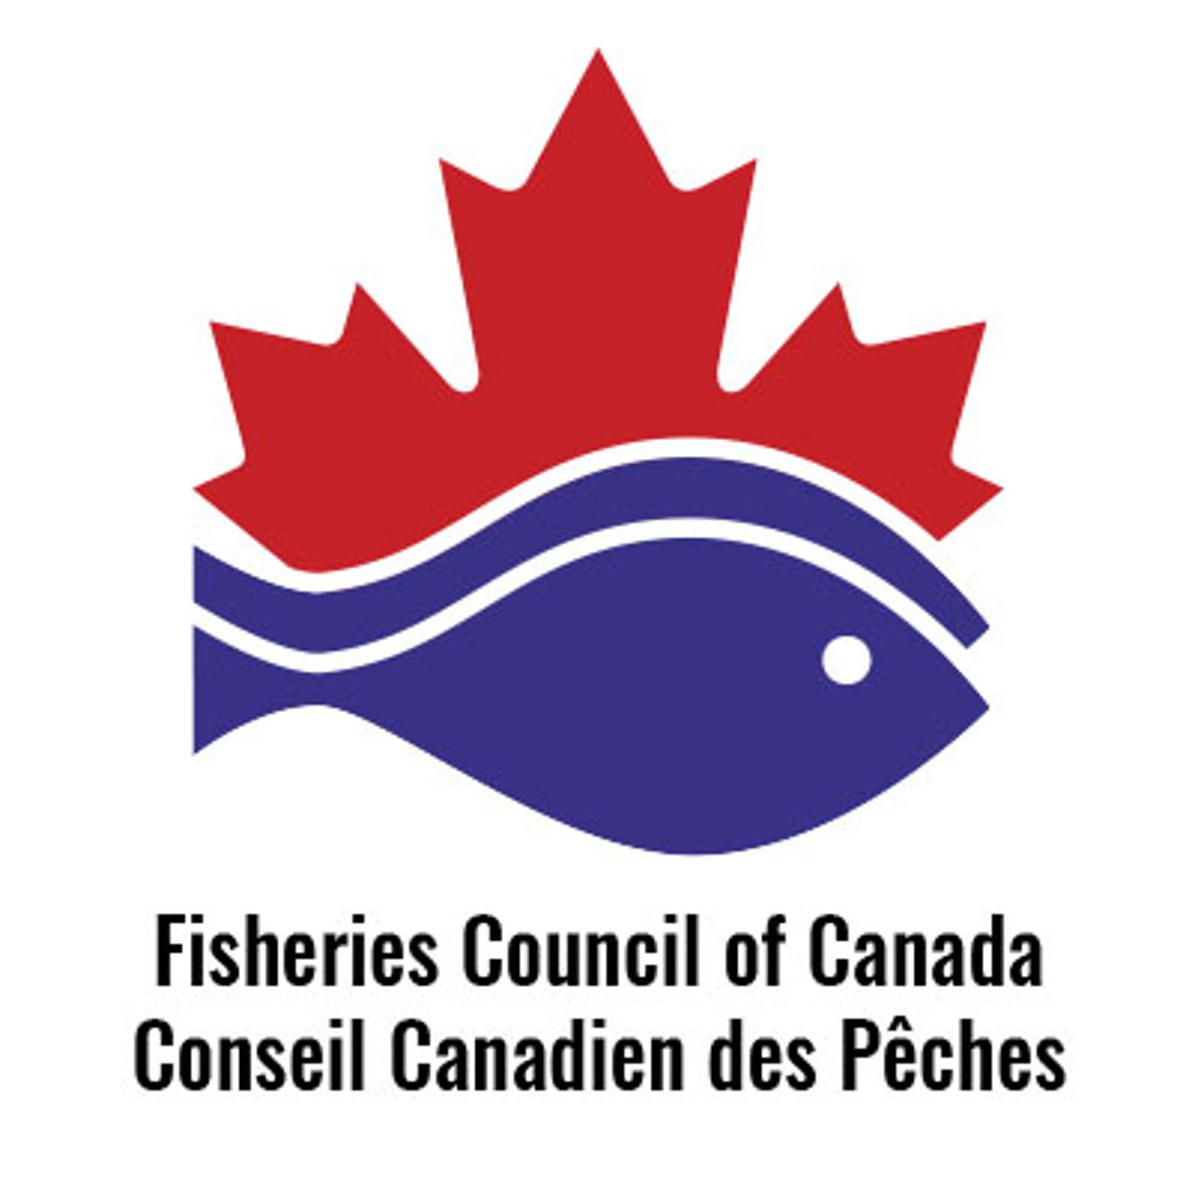

In partnership with National Fisheries Institute

Fisheries Council of Canada (FCC) is pleased to announce the 2022 Future Leaders Canada Program with support from the National Fisheries Institute.

Seafood and its sustainability are essential to Canada. 90,000 Canadians earn their living directly from seafood sector. The Future Leaders Canada curriculum will help develop the emerging leaders in the Canadian seafood industry through networking, programming and unique experiences along the supply chain.

The 2022 Program will kick off with an orientation breakfast in Boston during the Seafood Expo North America; and three three-day sessions, from May through August, with graduation taking place at the Fisheries Council of Canada Annual Conference in October. Each FCC Future Leaders Canada session is designed to enhance industry knowledge and leadership skills in the areas of government relations, production, sales, marketing and the seafood community broadly. The Future Leaders Canada participants will visit Ottawa, ON, Chicago, IL, and Halifax, NS, and their surrounding areas. In addition to the in-person sessions, the program will have two virtual sessions focusing on Sustainability and a tour of a state-of-the art, green class offshore groundfish vessel.

FCC intends to be in person for all sessions; but reserves the right to hold virtual sessions if it is in the best interest of FCC members and staff.

What a Future Leader Should Expect

The Canadian seafood industry is diverse in geography, in harvest type, and in size of company. This program seeks to expose Future Leaders Canada participants to the various aspects of the seafood industry and allow ample opportunities for networking with classmates. In addition to facility tours, each class is shown several one-of-a-kind experiences on Parliament Hill and with retailers and restaurants (their customers’ customers). Be prepared for a challenging and rewarding experience with a full and engaging agenda.

What is Expected of a Future Leader

A Future Leader should conduct themselves professionally and with integrity at all times when traveling, including after-hours social outings. Participants are held to the highest standards and are expected to treat each other and all others with respect and consideration. A successful Future Leader will be prepared, on-time, and professional throughout each session.

Tuition

FCC Members will invest $3,940 CAD/$3,200 US in their future leadership. The investment fee for non-FCC Members is $5,940 CAD/$4,800 US. The tuition includes all sessions. Participants are responsible for hotel, travel, and some meal expenses.

To apply to be a Future Leader of the Canadian seafood community:

- Complete the attached application form.
- Attach a one-page written bio of yourself, your seafood experience, and why you would like to be a Future Leader.
- Include tuition payment made payable to National Fisheries Institute. (Please note there is a 5% surcharge for credit cards and will be processed in US dollars)
- The deadline for applications is 28 January 2022. There will be no refunds after attending the first session.
- If you are selected to be in the Future Leaders Canada Class of 2022, you will be notified no later than 1 February 2022.

For questions, contact NFI’s Gerrie Thomas, Director (1-703-752-8888, gthomas@nfi.org) or FCC’s Paul Lansbergen (1-613-727-7450, plansbergen@fisheriescouncil.org)

FUTURE LEADERS CANADA

Dates and Preliminary Curriculum

NETWORKING BREAKFAST: BOSTON, 14 March 2022
Join the Class of 2022 for a Networking Breakfast on 14 March during the Expo.
Note: Not required for those not attending SENA.

SESSION I OTTAWA  1-4 May 2022  3 nights/3 days  - Networking: Meet your fellow leaders  - Government Relations: Understand how Parliament and governments impact the fishing community  - Communications Training: Learn “hands-on” how to handle the tough media questions and how to meet with government officials | 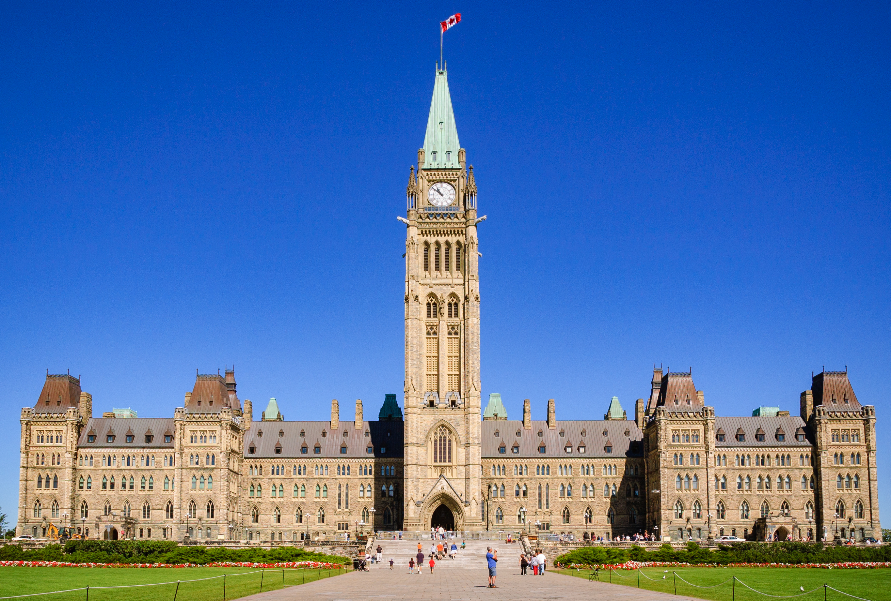
- Fisheries Council of Canada Leadership: Understand how your company’s investment in FCC helps your company and the seafood community
- Embassy Visit(s): Understand how Canada’s export strategies benefit the seafood industry
- Indigenous Reconciliation: A session on the Government of Canada and its commitment to Indigenous Peoples
- Port of Entry Tour: Meet with US government officials to learn the evolving regulations to get Canadian seafood into the U.S. market

SESSION II CHICAGO
5-8 July 2022
3 nights/3 days (Note: Valid passport required)

- Culinary Event: So you caught fish. And you can decently fillet it. Now test if you can actually cook it with the sizzle that makes a restaurant guest want to pay top dollar for that Canadian seafood
- Cold Storage Tour: Gain an appreciation for the logistics challenges once seafood leaves the dock and Canadian processing plant
- Broadline Distributors: Understand the expectations of large broadline distributors of
the seafood supply chain, inducing Canadian harvesters.
- Seafood Specialty Distributors: Gain an appreciation for how specialty distributors differentiate themselves from broadliners, and how Canadian seafood companies can gain access to these niche marketers
- Chef Discussion: Discuss with chefs their evolving demands of suppliers, from an expectation of documented sustainability through to help with identifying new species to serve guests
- National Retailer Visit: Learn from a major retailer how they seek to make seafood simpler and easier for U.S. consumers to enjoy in home.

SESSION III Halifax, NS
23-26 August 2022
3 nights/3 days

- Export Logistics Tours: The Halifax airport and seaport have both expanded to accommodate growth in seafood exports.  - Processing Plant Tours: Each packing plant brings its own experiences and insights in getting Canadian seafood from the boat to a form the North American and global consumer wants. | 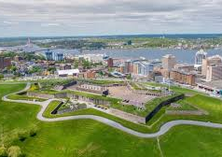
- Aquaculture operations: Learn about the aquaculture production in the Shelburne area.
- NS Community College – School of Fisheries in Shelburne. Learn about formal training programs at the college
- Discussions with Sector Experts – Nova Scotia is home to some notable sector experts from which you can gain from their insights.

FUTURE LEADERS CANADA

2022 Key Dates

Prior to applying to the program, please make sure you are available to attend all sessions. The key to your success will be full participation in the program

13 December 2021
Application Process Opens

28 January 2022
Application and Payment Deadline

31 January 2022
2020 Future Leaders Canada Class Announced

14 March 2022
Networking Breakfast Boston, MA at Seafood Expo North America (optional)

1–4 May 2022
Future Leaders Canada Session I Ottawa, Ontario

June 2022
- 7 June: Virtual tour & presentation of a state-of-the art, green class offshore groundfish vessel
- 28 June: Virtual presentation and conversation on Understanding Sustainability and Seafood

5-8 July 2022
Future Leaders Canada Session II Chicago, Illinois

23-26 August 2022
Future Leaders Canada Session III Halifax, Nova Scotia

5-6 October 2022
A graduation and recognition ceremony will be part of the 2022 Fisheries Council of Canada Annual Conference in Ottawa
FUTURE LEADERS CANADA

Future Leaders Canada Class of 2022 Application

Name

Company

Position/Title

Years in the Seafood Industry

Business Mailing Address

Cell Phone

Email Address

Sponsoring Member
(for Non-FCC Members)

Emergency Contact and Phone

If accepted into the Future Leader Canada Class of 2022, I agree to attend and actively participate in each session. I commit to conduct myself professionally and with integrity, treat all with respect and consideration, and be prompt. I agree to FCC/NFI taking photos to use for promotional purposes.

Applicant’s Signature/Date ______________________________________________________________
Supervisor’s Signature/Date _____________________________________________________________

Send Application, Biography, and Payment to:
National Fisheries Institute
Attention: Gerrie Thomas
1544 Spring Hill Road, #10763, McLean, VA 22102

